- amazon leadership principal question bank.docx
- Mentoring | Canidate Interview solution architect igotanoffer
- My Examples of Amazon 14 Leadership Principles.docx
- Amazon Behavior Interview Mentoring.pptx
- https://blog.dayone.careers/amazon-interview-questions/ (Questions for LP)
- https://www.rupeshtiwari.com/cloud-solution-architect-technical-interview-questions/ (Technical Question Bank)
- My profile: https://igotanoffer.com/en/coach/rupesh

23 Oct 2024
I have done only 15 classes , he is my ideal https://igotanoffer.com/en/coach/robert today one candidate asked me for a personal session he asked to pay $115 directly on my paypal.

What is a solution architect?
A solution architect is a customer advisor. SAs help our customers through their digital transformation journey into cloud by taking into account their business pain points, deep diving on their current infrastructure and proposing solutions that are flexible and scalable . They are involved in Pre-Sales and are part of the WWPS organization. Their mission is to be trusted advisors that possess a balance of business acumen, analytical skills and in-depth technical skills.

Candidate Questions:
What is the expectation, deliverables of SA, who does design, who does implementation, after implementation who does the design validation?

You are the FACE (end to end architect) for your customer advocate.

Expectation - understanding business problem (CEO c-level director, vp), technical challenges, Then design AWS solution, be face of customer AWS, advocate
Deliverable - immersion days workshops to up skills, AB1 - discovery, AB2- create solution PPT diagrams, AB3 - POC (demo)
Implementation - SA no implementation, customer will, aws proserv SOW, support engineer , Specialist SA, Workshop team,

How many Managers?
Account manager
SA manager

Draw diagrams online

Behavioral Questions

Amazon Leadership Principles Question Bank: amazon leadership principal question bank.docx

My Examples for Amazon Amazon Leadership Principles Questions:
My Examples of Amazon 14 Leadership Principles.docx

Loop Round
2 LP and 1 Technical

Critical LPs:
- Customer Obsession,
- Deliver Results,
- Invent and Simplify,
- Have Backbone; Disagree and Commit,
- Learn and Be Curious, and
- Think Big

are significant predictors of L5/L6 SA QoH and should be included on all L5/L6 SA loops.

The results include six of the LPs on all L5 and L6 interview loops to optimize QoH. Historically, L5 and L6 SA loops have covered 8-10 LPs. Based on historical competency assignment, TA anticipates a desire to also include Earn Trust (83% of loops) and Dive Deep (77%). AWS is developing an SA Functional Interviewing program to standardize the LPs included in all L5 and L6 SA loops.

Phone Screening Competencies

PS Assessed skills
- Technical skills ( validating Dive Deep in this context)
- Deliver Results or Invent and simplify (choose one and drill in)

Agenda
- Introduction (5 minutes)
- Technical Domain #1 (15minutes)
- LP (15 minutes)
- Technical Domain #2 (15 minutes)
- Candidate Questions (5 minutes)

References:
Technical Solutions Architect Questions Answers reference for Phone Screening especially

https://www.rupeshtiwari.com/cloud-solution-architect-technical-interview-questions/#how-would-you-secure-the-cloud
https://www.rupeshtiwari.com/cloud-solution-architect-technical-interview-questions/

What is Zero Trust ?
https://cloud.google.com/learn/what-is-zero-trust

System design questions:
Framework to attack system design problem:
1. Ambiguity and requirements - ( UI, User Geolocation, Auth/Authn)
2. Comprehensive Solution and interactions - ( top down bottom up )
3. Boundaries - (compute and storage separate, 2 intensive apps must be on different servers.)
4. Scale - (10x rule, find bottleneck , fix them )
5. Alternative - (think of alternative design, pros-cons of various approach, 2-way door solution)
6. API design - (stream, batch, cache, auth/z, latency, compressing, idempotency)

Draw diagrams online

Design system team can send email to their customers.

What is the load?
Last year prime day 600 emails/sec ~ 100m a day
Is it order processing or do any other teams send email?
What does the email look like? How to tell what to send?
Hi chris, your xbox arrived on campus plz come to this location and pick
Will this system want to take the whole email or take a template and fill the spots?
What option do you think will be a good option?
Does amazon have the mail server or I have to draw?
Before going to the mail server can you tell me what are the other components u need?
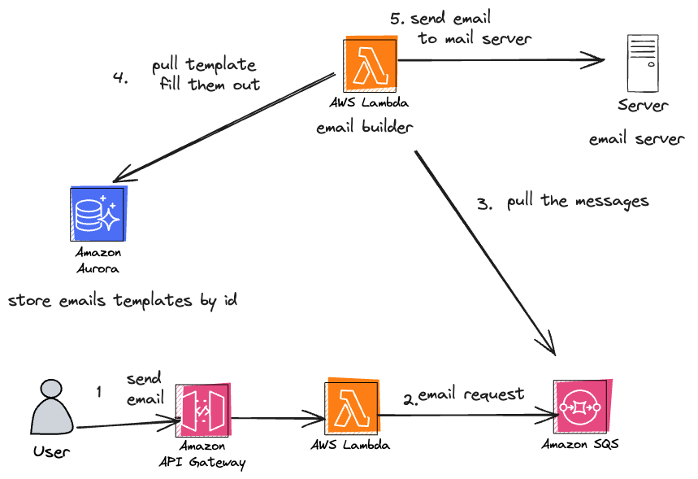

If you want to send 100 millions of emails what changes would you make?

Lots of servers pulling the emails from the SQS queue.
SQS at least delivers 1s. So u could ask them to send 1 email more than 1 time.
Short lived deduplication database (mail id which are sent) when we get a request if we send successfully then put on short lived db, and delete them after 24 hours. Before sending an email check this db. Use the template cache so no need to go to db every time.

What if the SQS sends all requests to just one server?

Design a fraud notification system
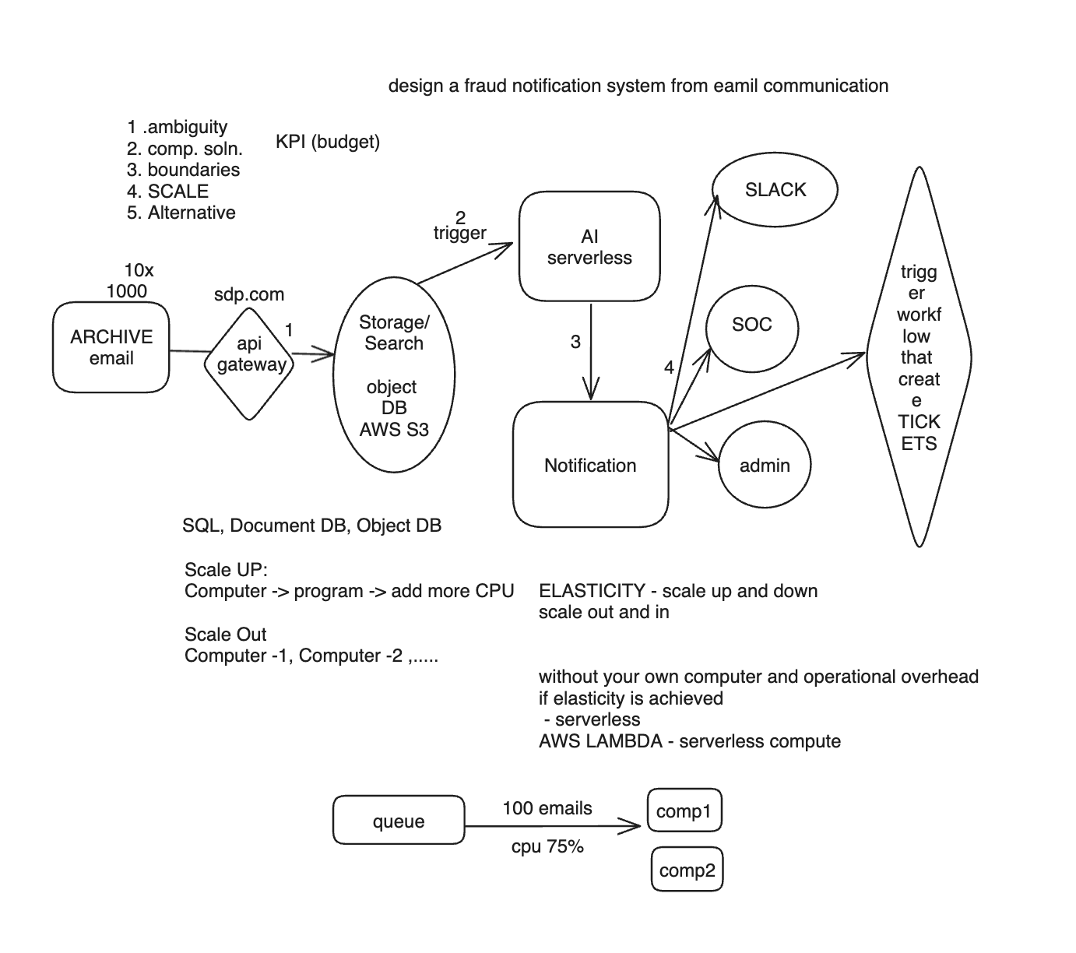

System Design Rubrics

Grading Rubric
This rubric is meant to be used as a guidance in areas to consider when evaluating candidates on the System Design competency. There is no absolute scoring on the criteria and they are equivalently important. It is about making decisions based on trade-offs and risks seen in the interview (and obviously the more mild strength/full strength data points the better).
Criteria | Concern | Strength | Example
Ambiguity & Requirements | Does not ask questions  Asks irrelevant questions  Fails to use the answers in the design  Questions attempt to trivialize the problem, not clarify requirements | Ask key questions to understand the problem and requirements.  Assumptions - if made - are reasonable and clearly stated. | If there is a web UI, relevant questions may include:  Who are the users  How many of them are there? Concurrently?  Is it on the internet?  Does it need authentication/authorization?
Comprehensive Solution | Stays at high level, unable to dive deeper. May suggest appropriate technologies without understanding why they are appropriate. Dive deep here. The why question is far more important than the what question.  Misses forest for the trees - focus on specific details without having a firm grasp on the overall problem  The connection between high level design and specific design details is unclear  Postpones the harder problems till later while focusing on the easier ones. | Make sure to understand the entire problem before diving deep.  Picks top-down or bottom-up approach as appropriate, and sticks with it.  Proposes appropriate solutions/components/technologies, and can explain why they are appropriate.  The candidate may not be familiar with specific technologies, but can still describe what they want. Saying "I'd like a HashMap wrapped in a service" is a fine substitute for "KV store" or "DynamoDB". | If the problem is well suited for a top-down approach, a great way to start would be with very few, very high-level building blocks (e.g. "Ingestion", "Processing", "Presentation") before further refining what those blocks do, before discussing table schemas and protocol-level details. After you are content that the candidate has a firm grasp on the overall problem, choose areas for them to explore in more depth.  Question buzzwords. If a candidate proposes to solve poor website performance with caching, make sure they consider whether data is suitable for caching in the first place. What happens if entries get evicted? If a candidate proposes to use noSQL to make the data store scale, ask them to articulate what, exactly, causes bottlenecks in a RDBMS for this particular use case.
Abstractions and Boundaries | Boundaries are fuzzy  Excessive coupling or duplication of functionality between components  Excessive interactions between the components (look for spaghetti of arrows)  Unclear which components are responsible for handling failures. | Components have clear boundaries  Interactions between the components are well defined and easy to explain | Imagine a Kindle. Can you clearly identify what's the responsibility of the Server, and what should run on the client?  Imagine you have a UI accessed by a billion people on the internet and another UI for your internal admins. Both could be hosted on the same web server. But should they?  Imagine you need to store some data. Does all of it belong in the same database, or even the same data store?
Scaling | Fails to anticipate bottlenecks  Cannot articulate why those bottlenecks exist  Has a hard time quantifying at what scale those bottlenecks might be encountered  Beware of Amazon bias. Many of us are keenly aware of seasonal variations in traffic, e.g. Q4 retail. Candidates may or may not have similar backgrounds. This can lead to false positives and false negatives. Use good judgment. | Able to explain which parts of the design are likely to become bottlenecks at scale  Can use order-of-magnitude to quantify those limits, and discuss potential solutions | If you need to perform 20 API calls in a sequence, did you recognize that ping time is non-zero, so the whole sequence will be expensive, and you can't just add servers to make it better?  How about trying to put a large volume of data in an RDBMS - where will this break, and why?  And if the proposal is noSQL, then what flavor (KV, doc, graph store, etc.) and why is it the best choice?
Staying on the rails | Fails to check whether the proposed solution would adequately satisfy the requirements | Keeps in mind the functional requirements, and ensures that the proposed solution satisfies them | Table scans, even on large data sets can be perfectly fine. But if your requirements state you need to present the results in a UI, table-scanning 10^9 rows is probably a dead end
Considering Alternatives | Has a specific approach in mind, and is reluctant to consider alternatives.  When discussing pros and cons, misses the more important considerations while focusing on the secondary ones | Is able to articulate pros and cons of various viable approaches.  If you are unsure whether they considered alternatives, ask. They may have missed them, or dismissed based on extensive prior experience.  Is able to commit to a chosen approach  Prefers two-way door solutions if available and appropriate. | When choosing whether to push vs pull data, the candidate should be able to think about how to handle outages, how to scale the receiving end, whether the sender or the receiver have a better idea when to initiate the transfer, and so on.
Avoidable Mistakes | Reaches multiple dead-ends en route to the solution, backtracking and doing much rework along the way.  Has to ask for additional requirements clarifications when reaching a dead end (related to: Requirements)  Similar to Scaling, use good judgment. Hindsight is great, but not everyone has had the same prior experience. Not all mistakes that appear avoidable to an average Amazonian maybe obvious to candidates with a different background. | Not only presents correct solutions, but is able to think a few steps ahead and look around corners  Avoids rework due to foreseeable mistakes.  To be clear, an iterative approach is fine, making mistakes is fine, but making mistakes that should've been obviously foreseeable indicates lack of experience. Interviewer needs to exercise judgment on what should be easy to anticipate for a non-Amazonian | The candidate proposes storing a large amount of data in RDBMS, recognizes ingestion will be a bottleneck, switches to a sharded KV store, just to realize he won't be able to pull the data efficiently enough to satisfy tight UI latency requirements, and finally throws a cache in there to make it all work.
 |  | What follows below is definitely scenario-specific. Which makes it even more non-exhaustive and merely a source of domain-specific ideas.
Data-Intensive scenario | Cannot explain the reasons behind the data store chosen, cannot choose a more appropriate one if asked to do so. Big partial credit for saying "I don't know, but if I were to wrap a HashMap in a service, it'd do the job, and the key would be X" | Uses appropriate data stores. Understands strengths and - more importantly - weaknesses of different data stores. Can dive deeper into schema design or sharding strategy if needed | Saying "I'll use a non-relational database because it's faster than SQL" is not enough.  Why is RDBMS slow for this particular case?  Which specific non-relational store (KV, document store, graph store, etc.) would work better?  Why, specifically?  Is it because transactions are a natural bottleneck, and we can - say - sacrifice 'A' in ACID?  Is it because you can use eventual consistency?  If it is because there's sharding, explain the sharding strategy
API design | Unable to go much farther than CRUD  Proliferation of methods that differ very little from one another  Or - vice versa - methods where behavior changes dramatically based on the parameters passed, with the more extreme cases devolving into RPC. | Comes up with clear API definitions  Considers batching and streaming if the requirements necessitate that  If appropriate, considers  authentication/authorization  idempotence  latency  suitability for for caching  separating low-latency calls that drive UI from high-volume, high-bandwidth API calls for data ingestion.  if data volumes are large, compression, serialization, and perhaps recovery from failures

